Week 2: Wireframes and GUI Design

2.1 User Interface Planning and System Design

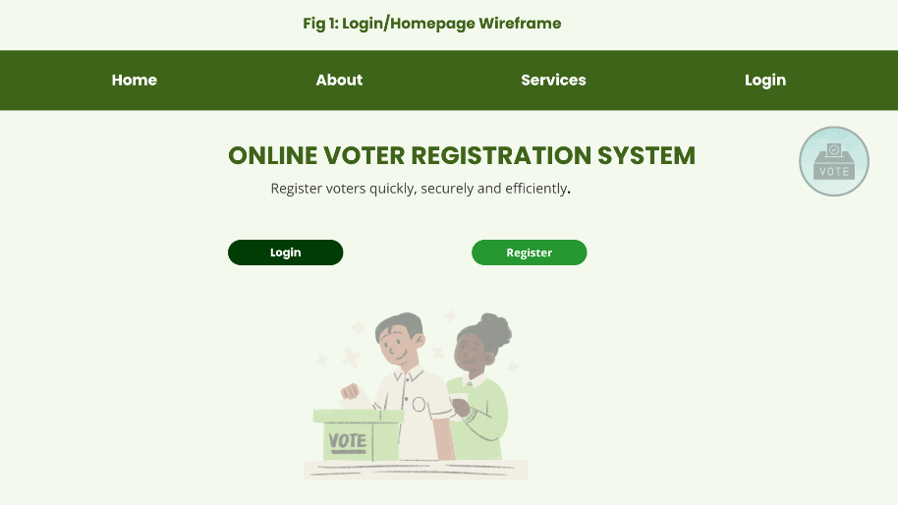
Figure 6: Login/Homepage Wireframe

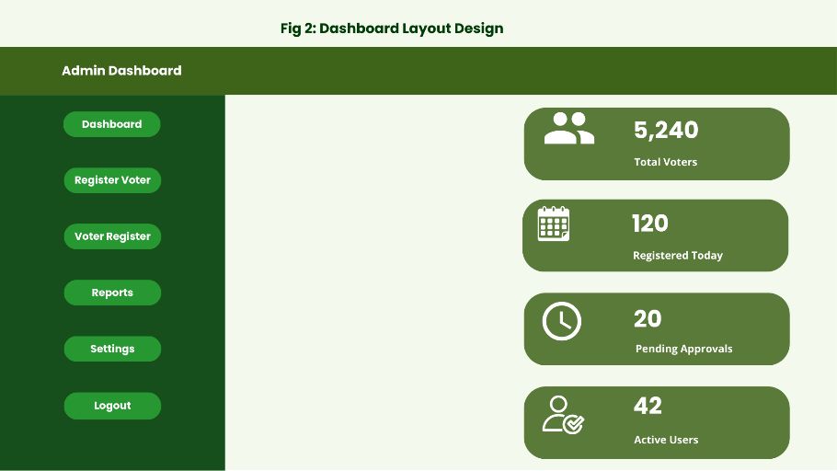
Figure 7: Dashboard Layout Design

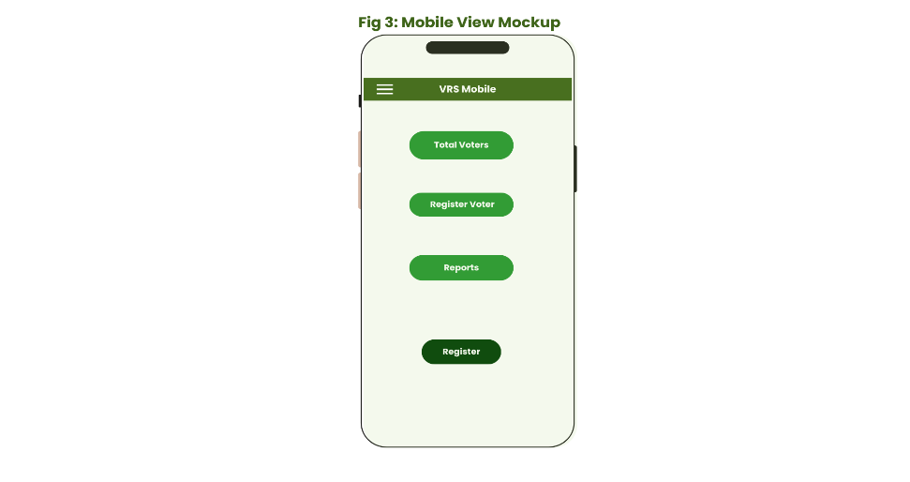
Figure 8: Mobile View Mockup

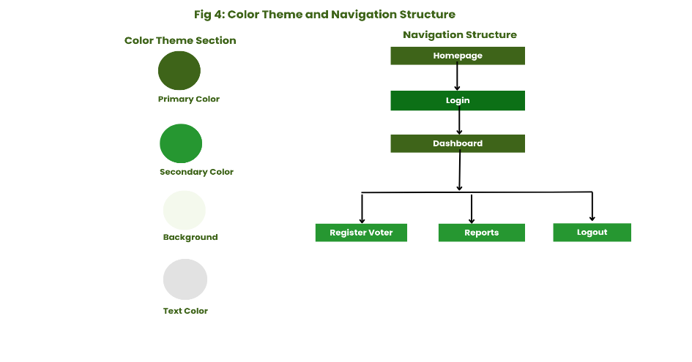
Figure 9: Color Theme and Navigation Structure

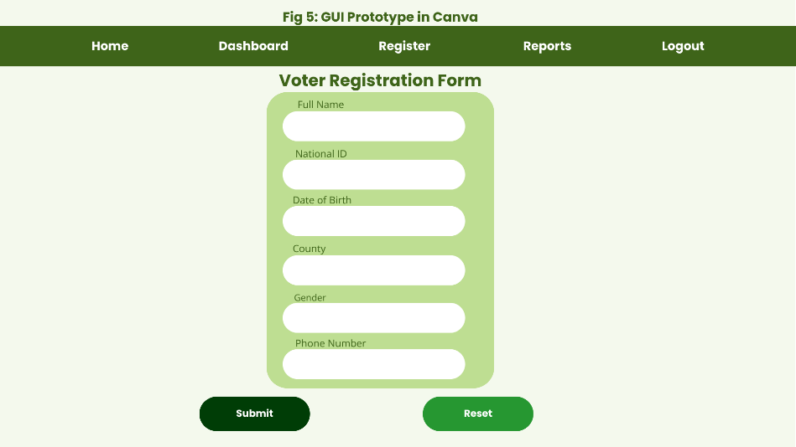
Figure 10: GUI Prototype in Canva

